LED PANEL LIGHT
Item No.:ES-PL-S1230
SPECIFICATION

LED Panel Light
Features:
- Super-thin, super-light and super-brightness.
- New design of optical configuration with high brightness, equal emitting surface, no flare, no flash and high efficiency for energy saving.
- Adapting current circuit design with stable working, reliable effect.
- Using optical panel material to improve the efficiency of light. High-thermal conductivity aluminum alloy to improve the efficiency of heat conduction.
- Perfect quality SMD, LED as light source with high light efficiency, speed activate, long lifetime.
- No noise and flash when working and frequent activation no affect light source.
- Warm white, natural white and cool white for choosing according to customer’s requirements.
- Beautiful, super- light design, and convenient installation.
- Long-life using can lower maintain cost.
- Different installation for choosing as customer’s requested.

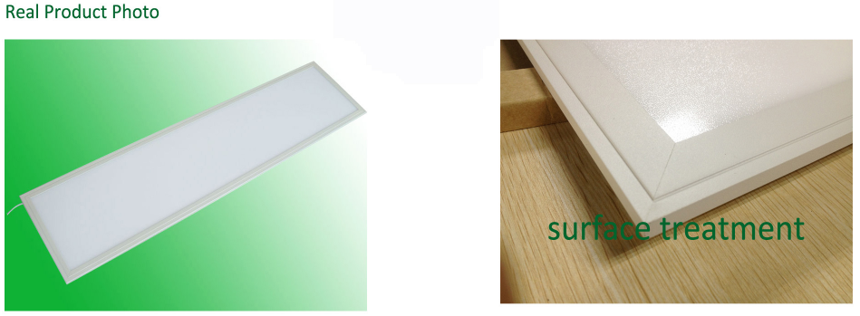

LED panel light specifications:
LED PANEL SPECIFICATIONS
NUMBER | ITEM | DESCRIPTION
1 | Input voltage | AC 100~240V
2 | Panel Input | DC:36-40V，Constant Current:1.05A
3 | Power consumption | 44W
4 | luminous flux | 3592lm
5 | Color | White
6 | Color temperature | 3000-6000K
7 | Life time | >50,000 Hour
8 | Operating temperature | -20ºC to + 50ºC
9 | Storage temperature | -30ºC to + 60ºC
10 | Certificates | CE RoHS FCC
11 | Size | 1195*1195*8.5 mm
12 | Protection Grade | IP20

Light Distribution Graph
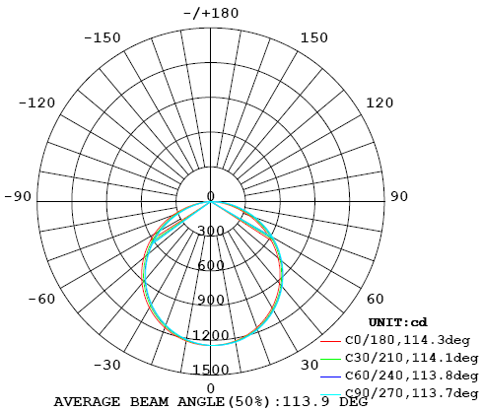

Panel Size:
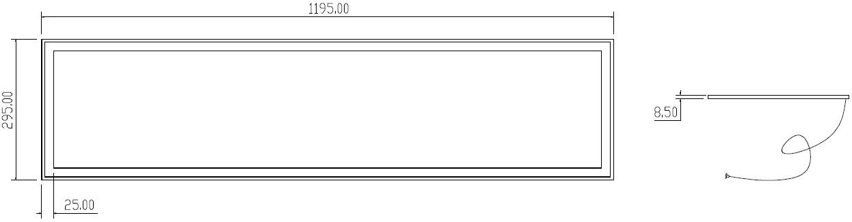

Electrical connection diagram:
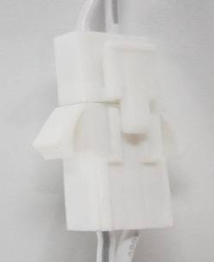
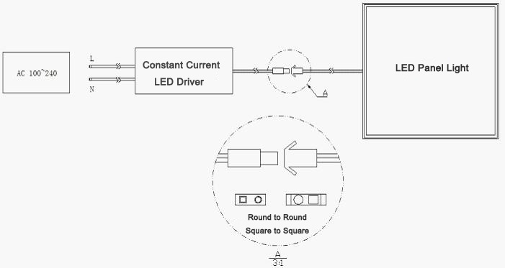
Installation:
1. Built-in installation
- Remove the ceiling where the LED driver and the panel light will be installed.
- Connect the Power Supply Cable.
- Carefully insert the LED panel light Along the diagonal direction into the removed ceiling.
- Turn on the AC power to light up the LED panel light.
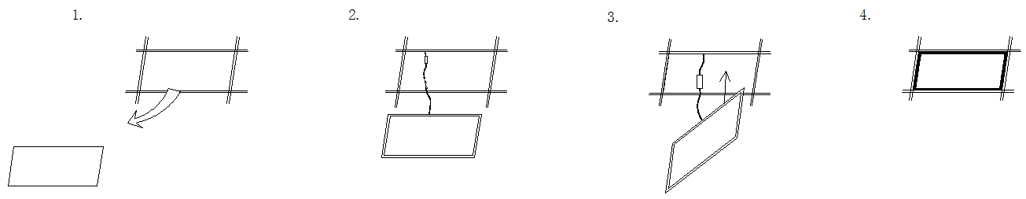
2. Wall surface mounted
- Install two screws on the wall,center distance as 487.5mm,
- Lock the hoist clamps into the panel light,
- Put the power supply on the wall or hide it dark channel,
- Put the panel light on the screws and adjust in proper position ,then connect the power.
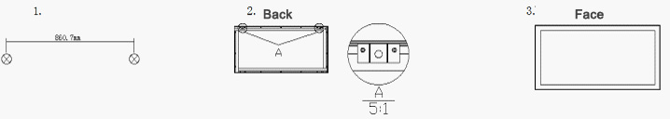
3.Pendant installation
- Lock the upper line locks on the roof
- Lock the underneath line locks on the panel light.
- Connect the upper and underneath line locks via steel wire rope, adjust the length, then connect the power.
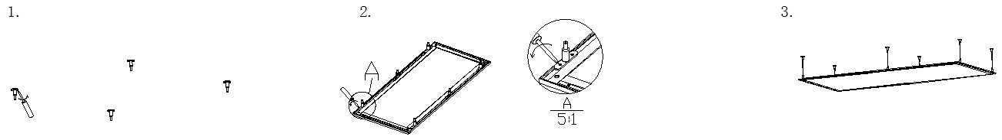

Package
5pcs/Carton
Quantity pcs | each piece in inner box and 5 pcs/carton
Weight KG | 21.0
Inner box mm | 1260x360x15
Out carton mm | 1280x380x110
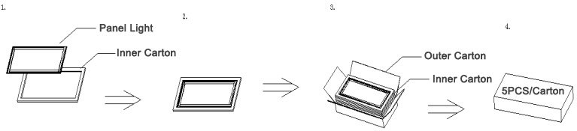

Attention
- Please be gentle when take out the product, in order to prevent scratch the surface.
- Please use screwdriver screw by hand,don't use the electrical screwdriver.
- Please stay away from fire or high temperature object when product installation.
- Please turn off the power before clean the lighting use dry dishcloth to wipe.
- Power supply, controller, tieline etc, to support our company's product, don't match others model.
- Let the children away from the product.
- When install or use the product meet the problem,pls ask the professional to maintain it and don't take apart the product without authorization.

